A DAY OF RECOLLECTION & PRAYER
Spiritual Talk and Adoration
with Fr. Javier O’ Connor, DCJM

“CALLED TO LOVE”
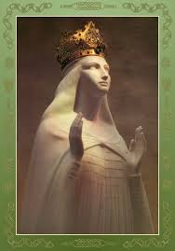
-------------------------------------

EVENT TITLE

EVENT SUB-TITLE
-------------------------------------
DATE
TIME
LOCATION
Address, City, St Zip Code
Reference: CALLED TO LOVE  by Fr. Jose Granados, DCJM & Carl Anderson  Chapter 9 - Witnessing to the Fullness of Love: Christian Virginity and the Destiny of the Body  Skype Meeting web link:  https://join.skype.com/ulRzMUwrEC1B | QUEEN OF APOSTLES CATHOLIC CHURCH  Online via Skype  Saturday  May 23, 2020  9:30 AM – 12:00 PM

